DATE …………………………………… STUDENT NO……………………………...…………..…

EXAMINATION CENTRE ……………………………………………..………...…………..…………..

THE SHIPPING AND FORWADING AGENTS’ ASSOCIATION OF ZIMBABWE
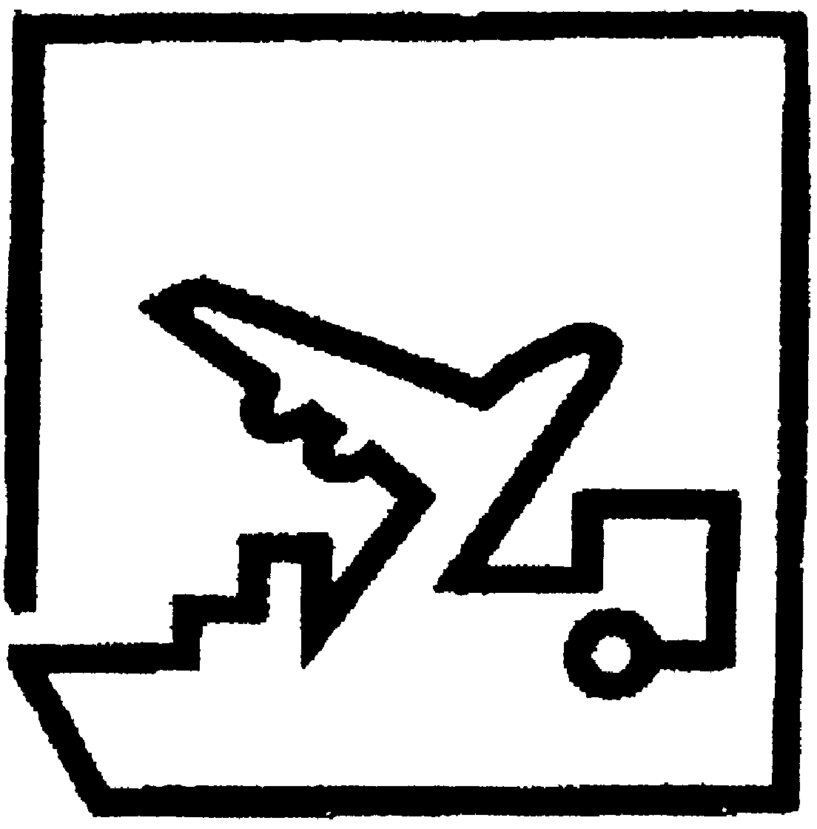

FREIGHT FORWARDING PRACTICE DIPLOMA

FINAL EXAMINATION

PAPER ONE

TRUE OR FALSE/SHORT ANSWER/MULTIPLE CHOICE

8 APRIL 2021

TIME ALLOCATION: (1 HOUR 30 MINS)

INSTRUCTIONS

- Answer ALL questions.
- Remember to write your student number in the space provided on this page and on all other answer sheets you submit.
- Follow the instructions indicated on each section.
- This paper carries 25% of the final examination mark.

FFP Diploma 2021 Final/P1 Student Number:……………………………

SECTION A: True or False:
Indicate the correct answer by putting a “T” of “F” in the brackets provided. T denotes TRUE and F denotes FALSE. Answer all questions from this part. Each question carries 1 mark.

- Both BIMCO and IMO are specialized agencies of the United Nations. True/False Answer ( )
- A boat or ship engaged in the tramp trade does not have a fixed schedule or published ports of call. True/False Answer ( )
- SFAAZ is a member of the Federation of Clearing and Forwarding Associations of Southern Africa (FCFASA). True/False Answer ( )
- A breach on the principle of insurable interest may take the form of material misrepresentation.
True/False Answer ( )
- Packing of goods is storing for future use while packaging is unitisation of packed goods for easy handling. True/False Answer ( )

- Covid-19 is not a business risk in Freight forwarding as cargo continues to be moved.
True/False Answer ( )
- When shipping dangerous goods, Air transport is the least restrictive mode. True/False Answer ( )
- A ‘through rate’ and the box rate are the same thing. True/False Answer ( )

- Container ships are an example of dry cargo vessels True/False Answer ( )

- Modal combination of land / Sea and inland is more convenient where lead time is a priority.

True/False Answer ( )
FFP Diploma 2021 Final/P1 Student Number:……………………………

- The track ballast that is found in rail transportation is the same as the ballast that is used in sea transport. True/False Answer ( )
- Containers have influenced the design of all other modes of transport.
True/False Answer ( )
- In Freight Forwarding business, economies of scale equates with maximising the utilisation of office space, of office equipment and other office assets. True/False Answer ( )

- Installing anti-virus software on the computer is a way of system backup.
True/False Answer ( )

- “Open Marine” policy is most ideal for once off shipments. True/False Answer ( )

- An “Ocean/ Marine” bill of lading is also known as a ‘Through bill of lading. True/False Answer ( )

- The Multimodal Transport Document is also referred to as Combined Document.
True/False Answer ( )

- A Freight Forwarder can perform all functions performed by a clearing agent, but a clearing agent cannot do some of the functions performed by Forwarder. True/False Answer ( )

- Europe has the biggest inland waterways network in the world. True/False Answer ( )

- Insurance is all about the sharing of risk. True/False Answer ( )
- The maximum axle weight on triaxle trailer is 28tons. True/False Answer ( )

FFP Diploma 2021 Final/P1 Student Number:……………………………

- An NRZ wagon loaded with ‘bagged’ maize from Beitbridge to Harare is treated as Dry Bulk Shipment.
True/False Answer ( )
- Danube River is the longest river in Europe and passes through ten EU countries
True/False Answer ( )
- Durban port is the deepest port in Southern Africa True/False Answer ( )
- Bogie is found in both air and rail modes of transport as it gives buoyance to the modes
True/False Answer ( )
- Road 3, in Zimbabwe links Harare to Bainbridge True/False Answer ( )
- Automated Inventory tracking system is an ICT tool that help in tracking road trucks
True/False Answer ( )
- Lloyd’s of London is an insurance company. True/False Answer ( )
- Movement of abnormal loads is regarded as a project, which in most cases might not recur
True/False Answer ( )
- Suez Canal lies between South America and North America. True/False Answer ( )

[TOTAL SECTION A: 30 MARKS]

FFP Diploma 2021 Final/P1 Student Number:……………………………

SECTION B: Short Answers.
Write your answers by in the spaces provided. Marks are indicated at the end of each question.

- FIATA acronym stands for? (1 mark)
…………………………………………………………………….…….………………………………….
……………………………………………………………………..……………………………………….

- List 3 risks that the importer/exporter may be exposed to in International Supply Chains. (3 marks)

- ………………………………………………………………………………………………...………
- ……………………………………………..…………………………….……………………………
- ……………………………………………………………………………………………...…………

- List any 3 trading blocs that cover the Africa region. (3 marks)
- …………………………………………………………………………………………………………
- …………………………………………………………………………………………….……………
- …………………………………………………………………………………………………….……
- NVOCC stands for….. (1 mark)

…………………………………………………………………………………………………………………………………………………………………………………………………………………………

- What is a Freight Forwarder? (1 mark)

……………………………………………………………………………………………………………...

……………………………………………………………………………………………………………..

…………………………………………………………………………………………….………………..

FFP Diploma 2021 Final/P1 Student Number:……………………………

- List two functions of an Air waybill. (2 marks)

- …………………….……………………………………………………………………………………
- ………………………………………………………………………………………………………….

- List 4 ways in which a Freight Forwarder can remain competitive given the fierce business environment they operate in. (4 marks)

- ……………………………………………………………………………...……………………….…
- ………………………………………………..……………………………………………………..….
- ……………………………………………………………………………………………….…………
- ………………………………………………………………………………………………………….

- List any 3 FIATA Documents that simplify freight logistics (3 marks)

- …………………………………………………………………………………………….….………
- ………………………………………………………………………………………………..………
- …………………………………………………………………………………………………………

- For easier of reference the worlds five continents have been regrouped into three areas. Which continent fall under the following areas? (3 marks)

Area 1 …..…………………………………………………………………………..………………………
Area 2 …..…………………………………………………………………………..………………………
Area 3 …..…………………………………………………………………………..………………………

FFP Diploma 2021 Final/P1 Student Number:……………………………

- List the 3 main features of multimodal transport. (3 marks)
- …………………….……………………………………………………………………………………
- ………………………………………………………………………………………………………….
- ………………………………………………………………………………………………………….

- List / Name one disadvantage of Reverse Logistics. (1 mark)
…………………………………………………………...………………………………………………………………………………………………………………………………………………………………...

- What is a Hinterland? (1 mark)
……………………………………………………………………………………………………...…………………………………………………………………………..………………………………………….
- List any 3 types of vessels that ply inland waterways. (3 marks)
- …………………………………………………………………………………………………………
- ………………………………………………………………….………………………………………
- …………………………………………………………………………………………………………

- What is the relevance of the container rating plate to the Freight Forwarder? (1 mark)
..............................................................................................................................................................................................................................................................................................................................................

- What is TT Club? (1 mark)
…………………………………………………………………………………………………………………………………………………………………………………………………………………………
FFP Diploma 2021 Final/P1 Student Number:……………………………

- Briefly define the following terms as they apply to rail transport:

- Rolling stock (1 mark)
………………………………………………………………………………………………………………………………………………………………………………………………………………………………………………………………………………………………………………………………………
- Rail Consignment Note (1 mark)
………………………………………………………………………………………………………………………………………………………………………………………………………………………………………………………………………………………………………………………………………

- Mention any 3 factors that should be considered when tariffing / costing using any mode of transport. (3 marks)

………………………………………………………………………………………………………………………………………………………………………………………………………………………………………………………………………………………………………………………………………

- Which mode of transport is friendly in moving dangerous goods and why? (2 marks)
………………………………………………………………………………………………………………………………………………………………………………………………………………………………………………………………………………………………………………………………………

FFP Diploma 2021 Final/P1 Student Number:……………………………

- Identify the dangerous goods label below and state where it is used. (2 marks)

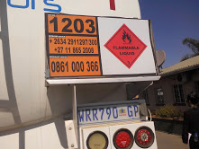

………………………………………………………………………………………………………………………………………………………………………………………………………………………………………………………………………………………………………………………………………………………………………………………….………………………………………………………………………………

[TOTAL SECTION B: 40 MARKS]

FFP Diploma 2021 Final/P1 Student Number:……………………………

SECTION C: MULTIPLE CHOICE:
Answer all questions in this section. (Each question carries 1 marks) Indicate the correct answer in the brackets provided by putting the correct paragraph number. Do not circle or tick the correct answer.

- Which European river has the fall/ rapid used to generate Hydroelectricity?

- Elbe.
- Zambezi.
- Rhine.
- Thames.
- Yellow . Answer ( )
- Panama Canal is………………….

- The canal that links the Atlantic and the Pacific Ocean.
- The canal that links Mediterranean and Red sea.
- The canal that links Mediterranean and the Indian Ocean.
- The canal that links Mediterranean Sea and the Atlantic Ocean.
- The water channel that links Arctic to Antarctica. Answer ( )

- Which the carrier’s maximum liability is as outlined in the CMR convention of 1956?

- 17.33 SDR per kg gross weight.
- 8.33 SDR per kg gross weight.
- 19.00 SDR per kg gross weight.
- 8.50 SDR per kg gross weight.
- 19 SDR per kg gross weight. Answer ( )

- Which INCOTERM has the least costs to the exporter / seller?

- Ex Works (place).
- CPT (place).
- CFR (place).
- CIP (place).
- DDP (place). Answer ( )
FFP Diploma 2021 Final/P1 Student Number:……………………………

- An LCL container is one which is utilised to carry ............., each of which originates from a different supplier.

- One Full Container Load from single consignor.
- One Full Container meant for one Consignee.
- A number of small consignments.
- Full loads meant for single importer.
- None of above. Answer ( )
- A contract of sale that requires the Seller to organize transportation is which of the following?

- Carrier Haulage.
- Merchant Haulage.
- Subcontracts.
- Cooperatives.
- None of above . Answer ( )
- One of the strategies recommended to counter new entrants (Porter’s five forces model) is called which of the following?

- Economy of distance.
- Economy of scale.
- Imitation.
- Ignore.
- None of above. Answer ( )
- FIATA form denoted by SIC is which of the following?

- Shippers Declaration for the Transport (Dangerous Goods).
- Shippers Intermodal weight Certificate.
- Shippers instructions regarding carriage.
- Shippers international document.
- None of above. Answer ( )
- The acronym TACT is which of the following?

- Tariff Correction Treat.
- The Air cargo tariff.
- Tariff accountable convention.
- The accommodating rate.
- None of above . Answer ( )
FFP Diploma 2021 Final/P1 Student Number:……………………………

- In Air transport, short shipment not resulting from overbooking is called ………………………..?

- Airfield Black.
- Bumping.
- Next Flight Out.
- Delayed Flight.
- None of above. Answer ( )

- The acronym WPA as applied in insurance is which of the following?

- With Particular Average.
- Without Particular Average.
- Warehouse Part Average.
- Worldwide shipper identifications.
- None of above. Answer ( )

- According to the UN handbook, modes of transport means which of the following?

- The type of vehicle used for transport.
- The transport by one mode of transport.
- The method of transport used for the movement of goods.
- Any mode apart from pipeline.
- None of above. Answer ( )

- Which of the following Dangerous Goods Classes is incorrect?

- Class 6 - Toxic and Infectious Substances
- Class 7 - Radioactive Material
- Class 5 - Oxidising and Infectious Substances
- Class 8 - Corrosives
- None of the above. Answer ( )

- What is consolidated/ groupage cargo?
- A large consignment packed in several containers.
- Non containerized goods carried loose on trucks.
- Huge machinery disassembled for ease of carriage.
- Small individual consignments imported in one container.
- None of the above. Answer ( )
FFP Diploma 2021 Final/P1 Student Number:……………………………

- Which UN protocol should be considered (takes priority) when shipping dangerous goods in road/ sea and Air combination?
- RID.
- ADR.
- ADNR.
- Warsaw.
- Hamburg rules . Answer ( )

- Soo locks are -
- Devices that are used at deep sea ports to allow big vessels to load and offload.
- Devices that are used to regulate water levels in the inland ports in making vessels move in different levels.
- Devices that are in shallow sea ports to allow small vessels to load and offload.
- Locks put on entrances to cargo areas in ships.
- None of the above. Answer ( )

- From the following extract “4GV/X6/S/08/USA/+AQ2121” the letters “X6” refer to…

- Packing Group.
- Packing Group tested and maximum gross mass (kg).
- Dangerous Goods Class.
- Packing Group and Dangerous Goods Class.
- None of the above. Answer ( )

- Which statement defines Constructive Total Loss?

- Occurs when the assured’s goods are destroyed/damaged to the extent that they have ceased “to be a thing of the kind”
- Occurs when goods are reasonably abandoned because their actual loss seems unavoidable or the cost of making good the loss would exceed the insured value of the goods.
- Occurs when a part of a consignment is lost or damaged but the rest of the consignment arrives safely at its destination.
- None of above.
- All of above. Answer ( )

FFP Diploma 2021 Final/P1 Student Number:……………………………

- Load securement and stowage plan is very import in international logistics because......

- The contents of a container are subject to acceleration, deceleration and centrifugal force.
- In Ocean transport, gravitational forces are rife as the ship/vessel rolls and pitches.
- Goods should be stowed in such a way that they will not shift their position during transit.
- All of above.
- None of above . Answer ( )
- Multi-sectorial (when applied in Multimodal transport) means which of the following?

- Encompassing the problems and viewpoints of Governments, private industry and public.
- Ranging from rules, regulations and policies to customer service levels.
- Both of above.
- None of above.
- Does not apply. Answer ( )
- An airline or its agent can quote the charges that are fixed for the LD7 without reference to commodity loaded therein. This is which of the following?

- Classified rates.
- Specific commodity rates.
- ULD charges/ rates.
- General cargo rates.
- Deep sea container rate. Answer ( )
- The hire of entire ship from owner for a long period excluding the crew where the Charterer takes possession and control taking good care of vessel is best explained as;

- Demise charter party.
- Voyage charter party.
- Liner services.
- Rationalised conference.
- Tramping service. Answer ( )

FFP Diploma 2021 Final/P1 Student Number:……………………………

- Which is the ideal rail wagon / rolling for transporting cattle from Beitbridge to Mutare?

- HIS.
- DSI.
- L Truck.
- Hopper.
- PNN. Answer ( )
- Rail wagon axle weight is determined by which of the following?

- Gradient and off course of the cargo.
- Tare weight of the rolling stock.
- Size of the rail tracks on the section.
- What cargo can bear.
- All of above. Answer ( )
- Which is Zimbabwe National Rails line gauge?

- 1 067mm.
- 1 674mm.
- 1 520mm.
- 1 000mm.
- 1 066mm. Answer ( )

- WTO acronym denotes …………………………………….

- Worldwide Tracking Organisations.
- World Trade Organisation.
- World Transport Organisation.
- World Trade Order.
- None of the above. Answer ( )

- How do you identify a negotiable Bill of Lading?

- It is issued with a specific name indicated on consignee.
- It is usually send, by air, to the consignee as soon as goods are on board ship
- It is bearing name and ‘order of’ inscription on consignee box
- It is written / drawn with ‘order of’ on consignee box.
- None of above. Answer ( )

FFP Diploma 2021 Final/P1 Student Number:……………………………

- Sea cargo freight is determined by……..

- Destination
- Commodity
- Box rate
- CAF and BAF
- All of above. Answer ( )

- Diversification may take which direction?

- New service in new market.
- New service in existing market.
- Starting new business that is related or not related to what is the norm.
- Partnerships.
- All of above. Answer ( )

- How does one make sure She /He is the right recipient of the container?

- Check the seal and container coding and numbering that it correspond to import documents.
- Check the operational characteristics of the containers.
- By opening the container immediately after receipt.
- Verify the size and type of container against export documents.
- All of Above. Answer ( )

[TOTAL SECTION C: 30 MARKS]

